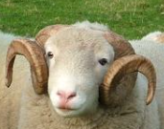
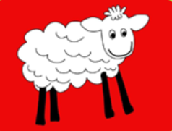
Half Term Curriculum Overview

Woodlands Class Autumn 1 2022

Place Value
Roman Numerals to 1000
Read Write and order numbers to 1,000,000
Round numbers to the nearest 10, 100 and 1000
Addition and Subtraction
Mental Strategies
Add numbers with more than 4 digits
Subtract numbers with more than 4 digits
Multi-Step problems
Multiplication and Division
Shape
The children will read The Girl Who Stole an Elephant
Introduce the novel: characters, setting, dilemmas. Discuss and evaluate language. Explore the character of Chaya. Prepare a Reader’s Theatre performance. Summarise the events in the story so far.
Revise rules for punctuating direct speech.
Revise how to use noun phrases to convey complicated information concisely.
Write a description of a setting using expanded noun phrases.
Writing and performing playscripts.

Tie dying fabric/investigating ways to change fabric
Develop skills in using clay
Cooking an Anglo-Saxon banquet
Angry Anglos and Vicious Vikings – Were the Anglo-Saxons and Vikings raiders or traders?
Map Work – Name and locate counties and cities of the UK,
Use 8 points of compass, 6 figure grid references, symbols and keys
Use field work to observe human and physical features in the local area.
English- Read x3+ (to include class book) Grammar homework 1x15 mins
Maths – 3x 10 minutes maths skills
Topic – Project work
The children will be looking at and testing a range of materials and learning about their properties and uses.
- compare and group together everyday materials on the basis of their properties.
- know that some materials will dissolve in liquid to form a solution.
- use knowledge of solids, liquids and gases to decide how mixtures might be separated, including through filtering, sieving and evaporating.
- give reasons, for the particular uses of everyday materials, including metals, wood and plastic.
- demonstrate that dissolving, mixing and changes of state are reversible changes.
- explain that some changes result in the formation of new materials,

History/Geography
Maths
English

Design Technology

PE

Hockey
Cross Country

CREATION/FALL
Creation and science: conflicting or complementary?
Homework

Mathematics

Homework

RE
English/Maths:
Spellings:
Reading:

Physical Education

Science

