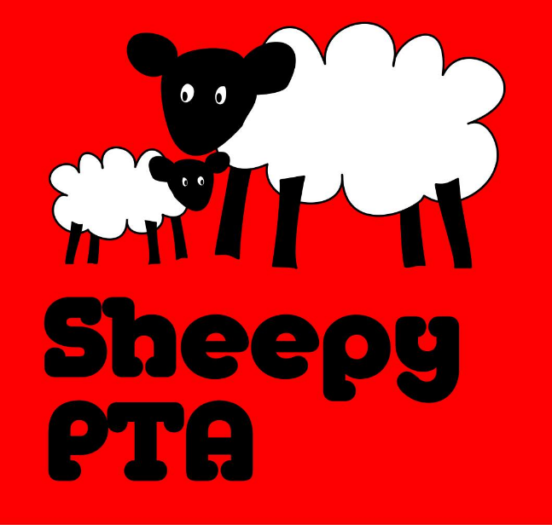

Sheepy Magna PTA
Tuesday 16th January – The Millers, Sibson

- Present: Eilish Gardner, Michelle Hill, Carly Baker, Chloe Mahon, Darren Marshall, Diane Lowe, Emma Frame, Katie
Apologies: Emily Smith, Dawn Otty, Corrine Clarke, Fiona Wright, Gemma Spencer.

- Matters discussed:
  - Carols round the tree – a good turn out despite the weather. All felt attendance was improved as the children decorated their own lanterns in school, and a bit of a push on social media. Great that the Church put on drinks and biscuits. Not a big money maker but had a lovely community feel. Diane to see whether all lanterns have been collected and to store them. Thank you to all involved.
  - Christmas Raffles – very successful. Good feedback from those who won hampers. Thank you to all who donated for the hampers, the teaching staff for making the hampers, all who sold tickets and all who bought raffle tickets.

- Matters discussed / events to be arranged:
  - Non uniform Day – ‘Wear what you love’
    - Confirmed for 14th February.
    - Chocolate or money donations (to be used as prized at Chocolate Bingo).
  - Chocolate bingo
    - Confirmed for 15th March at 6pm in Church.
    - Emily to bingo call.
    - Consider selling snacks (crips/cakes) and pens. To be discussed at next meeting.
    - Ensure advertise (use poster from last year) in village to increase turn out.
  - May Day – Eilish has spoken to Mrs Field. Mrs Field will liaise with other staff and come back to us. But initial thoughts were Pimms and scones stall (or something similar) to sell at a little May Day event.
  - Mothers Day/Fathers Day – All agreed that Emily should decide whether this is to continue as she organises this.
  - Sponsored inflatables – Michelle is taking part in an organised event in Wolverhampton (raising money for a different charity) in June and is encouraging PTA members and parents/carers to either get involved by taking part and choosing to raise money for the PTA, or sponsoring someone who has. Not a PTA organised event but one which the PTA could benefit from if people are willing to. Michelle has details if anyone is interested.
  - Scarecrow Festival – All agreed that it would be good to have a School/PTA Scarecrow. The date of the Scarecrow Festival is yet to be confirmed, but thought to be September time. All felt that a tractor themed scarecrow, possibly made of hay bales and decorated with lights in homage to our Countryfile appearance. Consider selling sweet cones and soft drinks. To be discussed further.
  - Christmas Wreath making – Carly suggested a wreath making event at the church in November / December 2024. All agreed that this was a good idea. Carly to talk with a florist who held an event in December 2023 and to report back.
  - Christmas party – discussed the potential for a Christmas party. To be discussed further.

- Treasurer:
  - Carly confirmed Christmas raffles made £580.
  - Carly thanked Emma for selling jigsaw puzzles on behalf of the PTA.
  - Query whether there were any donations from the candle parade?

- Other:
  - Try to develop a relationship with Tesco Atherstone.
  - Prepare a poster – what your PTA do for you / have done, to send home and put on social media. See what we already have – Emily may have something that can be amended/updated.
  - Look for existing PTA banner in garage before pricing up a new one. To be used at events – i.e. bonfire night, scarecrow festival etc.
  - Consider options for end of term at future meeting.
  - Queries raised as to what the ticket money for the Christmas plays is used for.

Next meeting
5th March, 7.30pm
The Millers, Sibson.
Please join us!

