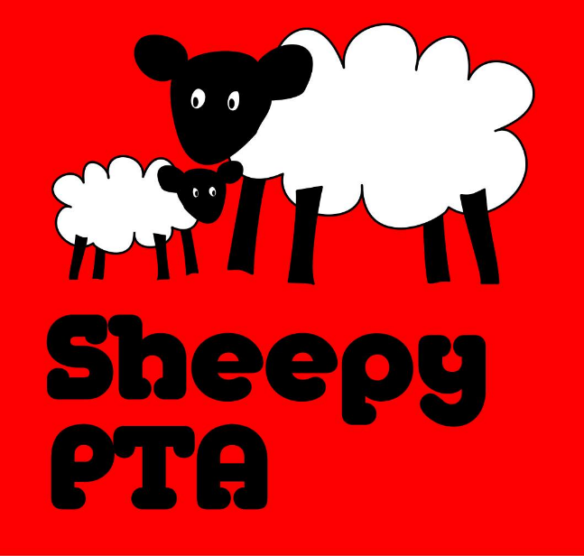
Sheepy Magna PTA
Tuesday 5th March – The Millers, Sibson

- Present: Eilish Gardner, Michelle Hill, Carly Baker, Chloe Mahon, Darren Marshall, Diane Lowe, Emily Smith, Corinne Clarke, Katie Oakley.
Apologies: Dawn Otty, Gemma Spencer, Emma Frame.

- Matters arising from last meeting:
  - Chocolate bingo – arranged for Friday 15th March, 6pm at the Church.
    - Bags are required to put chocolate prizes in.
    - Cakes to be bought / made for sale on the evening.
    - Tickets are £1 a book. £1 for the flier.
    - Bringing pens.
    - Arrive at 5.30pm to help set up.
    - Float, sum up machine, bingo tickets with Carly.
    - Free squash.
    - Mrs Andrews has bought some Easter Haribo should there be a chocolate allergy.
    - Small chocolate lolly to be given to children at the end of the evening who haven’t won.
  - Tesco – require a blurb about what we’re raising money for in order that we can be considered for the blue token scheme in store. Fiona to prepare this.
  - Christmas Wreath making – Carly to talk with a florist who held an event in December 2023 and to report back.
  - Sponsored inflatables – we have a few parents and children taking part and the justgiving page will be shared with parents. Hoping to raise £750. Good luck to all those taking part!
  - May Day – still unclear what is happening and what the PTA may do – further discussion with Mrs Field required.
  - Candle Parade – Emily confirmed that £27 was donated at the Candle Parade.
  - Christmas play ticket money – the PTA were asked what this money is used for. Emily advised it is used for things like mince pies at Christmas events that parents/guardians are invited to, leavers gifts etc.
  - PTA Banner – still need to look for existing PTA banner in garage before pricing up a new one. To be used at events – i.e. bonfire night, scarecrow festival etc.
- Matters discussed:
  - The Millers Charity of choice. The Millers have offered that Sheepy Magna PTA is one of their charity’s for the year. This is a very generous and gratefully received offer.
  - Scarecrow Festival and Sheepy Bonfire.
    - Darren in his capacity as a member of the Bonfire Society, asked the PTA if they would be interested in taking on the running of the Scarecrow Festival and the bonfire (the Bonfire Society has used the Scarecrow Festival to fund/part fund the bonfire).
    - All at the meeting agreed both were great events for the village, however there were numerous questions:-
      - Do we have capacity for such big events?
      - Have we the necessary skills and experience?
      - How many volunteers would be needed / would we have enough?
      - Health and safety issues / concerns. Who has health and safety expertise?
      - Would/could other community groups in the village work together to run these events?
      - Are the PTA Committee prepared to take on this responsibility?
    - It was suggested that Clara (Member of the Bonfire Society) comes to a PTA meeting so that questions can be asked to allow the PTA to make a decision on whether to take over / be involved in the running of these events.
  - Cake sale – To try and encourage more people to be involved, and to share the load, we thought that each class group could organise and run an after school cake sale, perhaps every half term. Portland will run the first class group cake sale after school on 19th April.

- Treasurer:
  - Carly advised that the Post Office on Coleshill Road will bank cash.

- Other:
  - Easyfundraising.org.uk – look into whether we could utilise this. Contributions are given to your charity of choice when purchasing online – no additional cost to the user.
  - Fun on the Field – possibly to be held on 4th July, 6-7.30pm, but details to be discussed/confirmed.

Next meeting 9th April, 7.30pm at The Millers, Sibson.
Please join us!

